LINQ (EFcore7-) Interceptor for Large Contains Clause (100K+ Values)
Bert O’Neill
Department: | Version 1 - IT\Software Support
Document Title: | Configure EF Core 6\7 For Bulk Contains - User Guide
Author: | Bert O’Neill
Date: | 24-May-2024
Version | 1.0
Email | Bert.ONeill@Version1.com
Document Goals | Provide an overview for developers, on how to quickly configure their Entity Framework Core 6 or 7 settings, to take advantage of a new feature currently added to EF Core 8 – using TSQL’s OpenJson command against SQL Server for large IN clauses.

Revision History

Date | Version | Description | Author
24-May-2024 | 1.0 | Initial draft | Bert O’Neill

Contents
Revision History 1
Introduction 3
Purpose 3
Scope 3
Prerequisites 3
Setting Up Test Database 4
Add Interceptor Using NuGet Package OR Add Class Directly int Your Project 4
Add Interceptor Class Uinsg NuGet Package 4
Add Interceptor Class Directly 4
Edit Entity Framework Core Settings to Call Custom Interceptor Middleware 4
Interceptor Code Explanation 4
ReaderExecutingAsync 4
Helper Classes 4

Introduction
This document provides an overview on how to configure your Entity Framework Core (6 or 7) settings to take advantage of the performance gains that OpenJson provides when using a large SQL IN clause of values.

Purpose
Your project maybe in a situation, where you now need to scale up and query more data using your cached values. But if you are not able to take advantage of EF Core 8, as the migration will entail more testing and development for your team – you have the ability to avail of OpenJson while still using EF Core 6 or 7 with this NuGet Package or directly incorporating the class into your codebase.

Scope
The scope of this document is to convey the configuration steps needed to start using OpenJson with EF Core 6\7.

Prerequisites
- An understanding of (Microsoft’s) TSQL
- An understanding of (Microsoft’s) Entity Framework Core
- An understanding of (Microsoft’s) Visual Studio or Visual Code
- An understanding of EF Core’s Pipeline & Interceptors
- An understanding on how to install NuGet Packages
- Have SQL Server (Developer Edition) installed.
- Have SSMS installed
- Have Visual Studio 22 Community installed.

Blog Files

SQL Script

Visual Studio Solution (Projects x3)

EF Core Interceptor Class

Setting Up Test Database
Run the following SQL script to:
- Create a new test database called LinqPerformanceDemo
- Create a new table called LargeTable
- Insert 1 million records into the table LargeTable
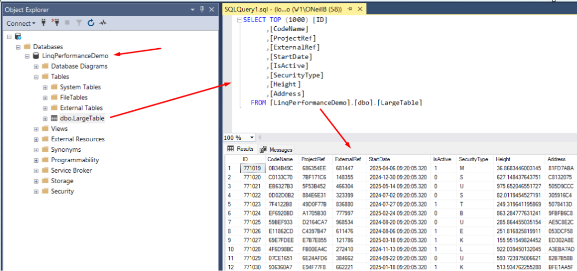

Benchmarks (Seconds)
Using a simple LINQ statement with a large IN clause and a small NOT IN Clause:
context.LargeTables.Where(itm => chunkData.Contains(itm.CodeName) && !_listNotIn.Contains(itm.ProjectRef)).ToListAsync();

In Clause - Batch Size | Standard EF Settings | OpenJson EF Interceptor
20K | 151 | 234
30K | 396 | 157
40K | Timeout | 132
100K | Timeout | 123
150K | Timeout | 99
200K | Timeout | 98
300k | Timeout | 91
500k | Timeout | 83
700K | Timeout | 86
1M | Timeout | 105

At 40K, standard EF failed with a timeout on the first IN clause:
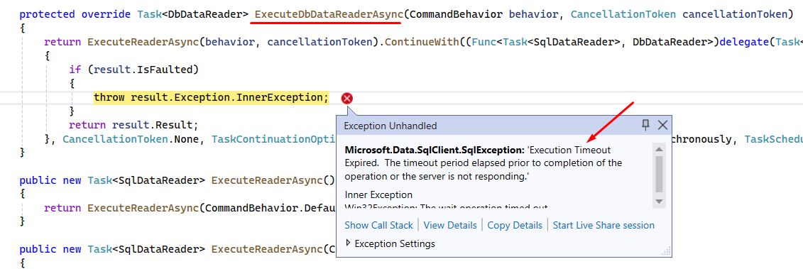

Add Interceptor Using NuGet Package OR Add Class Directly int Your Project

Add Interceptor Class Uinsg NuGet Package
The NuGet package is located here on Nuget.Org, with the User Guide on how to edit the EF settings within your project.
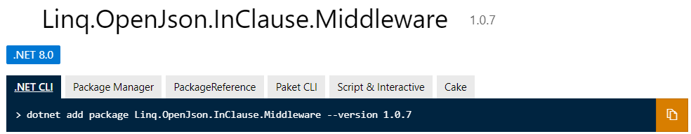
You can add the NuGet package within Visual Studio like a normal package, into your project – search for Linq.OpenJson.InClause.Middleware and click install.
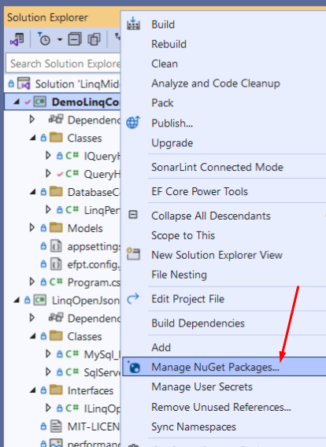

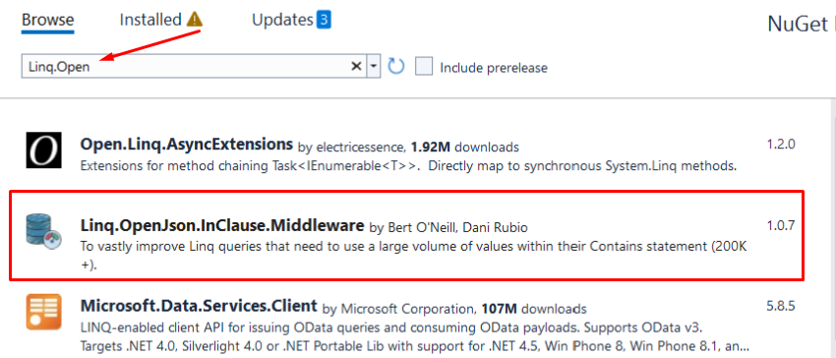

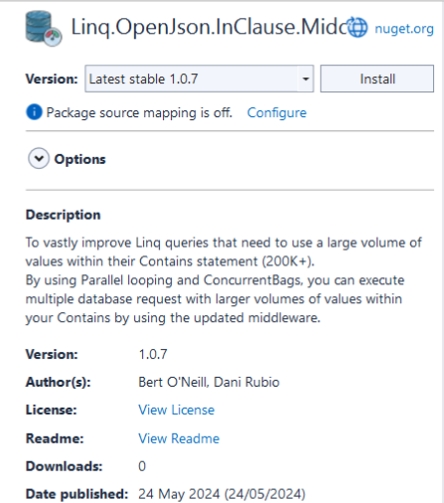

Add Interceptor Class Directly
If you open the attached Visual Studio solution you will see three projects, the project named DemoLinqContainsOpenJson is to demo and test the new EF interceptor.
The second project called LinqOpenJsonInClauseMiddleware, is the NuGet package contents and contains the interceptor override methods (ReaderExecutingAsync and ReaderExecuting).
The third project is just a database project, which contains the SQL script and a DAC for the database.
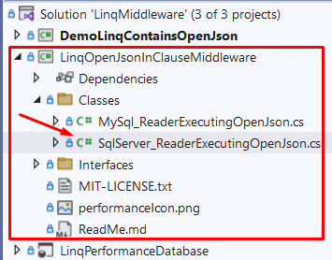
If you want to customise the code, for example increase the chunking limit from the default 20K to 25K, you can do this in the SqlServerReaderExecutingOpenJson class, by setting the constant MINIMUM_ITEM_SIZE.
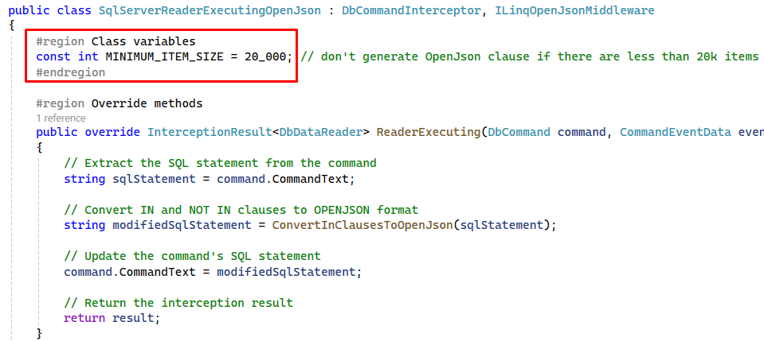

Edit Entity Framework Core Settings to Call Custom Interceptor Middleware

Interceptor Code Explanation

ReaderExecutingAsync | ReaderExecuting

Helper Classes

Example SQL Syntax Generated

Original EF Core SQL Syntax Generated (EFC 6\7)

New EF Core SQL Syntax Generated (EFC 6\7)

Miscellaneous

Acronym
Abbreviation | Meaning
EF | Entity Framework
EFC | Entity Framework Core
SQL | Structured Query Language
TSQL | Transact Structured Query Language

